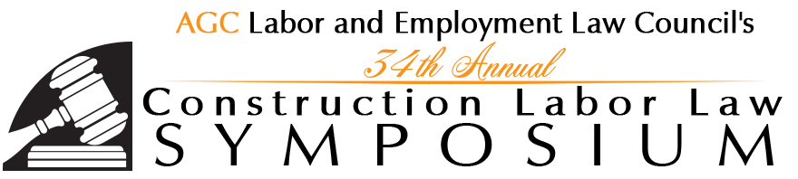
and
PRE-SYMPOSIUM WORKSHOP on DOUBLE-BREASTING

Handouts are posted in AGC’s Labor & HR Topical Resources library at www.agc.org/topicalresources.
You must log in (in the top left corner) as an AGC member to view the documents.

DOCUMENT | CATEGORY | SUBCATEGORY
Legality of the Anti-Dual Shop Clauses | Unions/NLRA | Double-Breasted/Dual Shop Operations
Benefit Fund Reactions to Double-Breasting | Wages and Benefits | Multiemployer/Taft-Hartley Benefit Plans and Trust Funds
 | Unions/NLRA | Double-Breasted/Dual Shop Operations
Formation of Double-Breasted Operations | Unions/NLRA | Double-Breasted/Dual Shop Operations
Formation of Double-Breasted Operations - Slides | Unions/NLRA | Double-Breasted/Dual Shop Operations
State Law Developments Impacting Double-Breasting | Unions/NLRA | Double-Breasted/Dual Shop Operations
Primer on Union Security Agreements, State Right-To-Work Laws and Related Subjects in the Construction Industry | Collective Bargaining | Union Security Agreements
Current Issues in Project Labor Agreements | Collective Bargaining | Project Labor Agreements
Current Issues in Project Labor Agreements - Slides | Collective Bargaining | Project Labor Agreements
Mandatory Arbitration and Class Action Waivers | Other HR Issues | Arbitration
Mandatory Arbitration and Class Action Waivers - Slides | Other HR Issues | Arbitration
Top Wage-and-Hour Issues Facing Construction Contractors | Wages and Benefits | Fair Labor Standards Act
Top Wage-and-Hour Issues Facing Construction Contractors – Slides | Wages and Benefits | Fair Labor Standards Act

